CPSC: 480 Software Engineering Exercise 2

9/21/22

A *Pokedex* is a searchable database of Pokemon. A Pokedex is a core feature of the Pokemon games and TV show, and many online resources compile data about each Pokemon into an exhaustive Pokedex. Examples include serebii.net, pokemon.gameinfo.io, pokemondb.net, pokemon.com, and many more. You may refer to any of these examples for ideas in developing your solution. In this exercise, you will:

* Refine and prioritize a given list of requirements
* Develop requirements models
* Develop a mock user interface for a portion of the product
* Identify tasks for a requirement and estimate the time needed to complete them
* **Not** need to construct any software or perform a significant amount of design work

# Software definition

Pokemon fans frequently need a reference for information about Pokemon. Due to the large number of Pokemon species – over 900 – even dedicated enthusiasts may sometimes encounter Pokemon with which they are not familiar. Furthermore, players attempting to collect Pokemon in a game need information about how they can obtain a certain Pokemon in that game. Completionists may also want to record what Pokemon they have already caught. More advanced players seeking to train their Pokemon to battle other players’ need even more detailed information about the Pokemon’s characteristics and suitability for battle. When developing a battle strategy, trainers may need to compare two different Pokemon species, explore how a given Pokemon fits with others in a given battle party, and analyze an individual Pokemon specimen for optimal characteristics within its species. Compared to information available in print, a software solution will allow users to more easily find the information they are looking for and will have a competitive advantage against opponents with less access to info.

# Information in the problem domain

A *Pokemon species* in a Pokemon game has the following information associated with it:

* A species name
* A photo
* A description of the Pokemon and trivia about it in English
* A range of possible values for six integers used in combat: HP, ATK, DEF, SpATK, SpDEF, Speed
* A list of possible moves the Pokemon can learn to use in combat
* A list of locations where the Pokemon can be found

A *Pokemon specimen* has the following information associated with it:

* A species
* A nickname
* Specific integer values for HP/ATK/Def/SpATK/SpDEF/Speed within the range of possible values
* A list of four moves from the list of moves the species can learn

Software Requirements

You are presented with the following list of requirements from the customer:

1. As a Pokemon trainer, I want to view the combat characteristics of a species.
2. As a Pokemon trainer, I want to enter specific details about a specimen I have and see how it compares to other possible specimens of its species.
3. As a player of Pokemon games, I want the ability to load a file containing a complete database of Pokemon species and info for a particular game.
4. As a Pokemon fan, I want the ability to browse a list of Pokemon species and search for a specific species by name.
5. As a Pokemon completionist, I want the ability to mark specimens I’ve previously caught, view a list of ones I’ve caught, and remove any that I no longer have or were incorrectly marked.
6. As a member of a household with multiple Pokemon fans and Pokemon games, I want the ability to switch user to maintain separate lists of acquired Pokemon for different users/games.

Behavioral Model

The following diagram captures the intended set of states and transitions for one possible software product meeting the requirements given, including states representing the main menu and search feature, and pages for application start, user login, data source configuration, and “My Pokemon”, with supporting intermediate states and state transition logic.

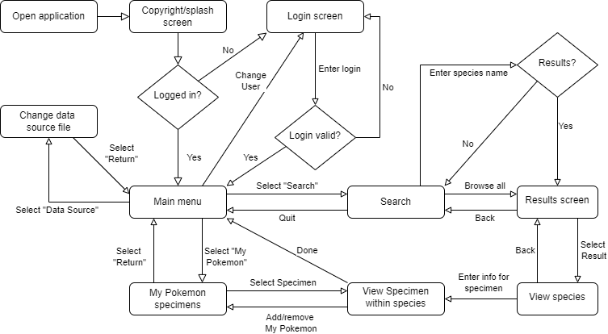

# Steps

Complete the following as a team. You may distribute and assign tasks as you see fit:

* Identify two functional requirements that might be implicit that you could propose to the customer so that you can validate that what you will build is going to satisfy their actual needs.
* Identify two non-functional requirements that could apply to this product.
* Propose a prioritization for this expanded list of requirements. Explain your reasoning.
* Develop* a scenario model (swimlane diagram) that captures the highest-priority requirement. Actors may include User, User Interface, Application, and Data Source.
* Break the **two** highest-priority requirements into a list of tasks that must be done to meet it. Estimate how many hours each task might take. The suggested method is for everyone to privately note their own estimate, then compare and take the median. This can be done with a deck of cards in a game of “[Planning Poker](https://www.planningpoker.com/answer/how-do-you-play-planning-poker/)”. If there is significant variation in estimates, discuss.
* List the objects that should be modeled for this product. Develop* a class model for them.
* Sketch a rough image showing a possible user interface for one state of the program.
* Compile artifacts into a pdf and have someone submit to Brightspace. Include the ordering of all requirements with explanation, list of tasks and estimates for top two, sequence model, class model, and sketch.

*The online diagram editor at https://draw.io is recommended for creating diagrams. It includes templates for all relevant diagram types. Students should also have access to Microsoft Visio through the University’s Office 365 subscription. Do not use a simple bitmap editor like Microsoft Paint for model diagrams, as these images are difficult to modify as requirements evolve. Diagrams do not need to use the formal UML standard but should clearly and accurately convey the relevant information.

# Grading

The exercise is due **Friday, Sept 23, at 11:59 PM.** Only one submission is needed per team and all teammates will share the same grade. Grades will be assessed as follows:

* 10% - Two reasonable, appropriate new functional requirements defined (5% each)
* 10% - Two reasonable, appropriate non-functional requirements defined (5% each)
* 10% - Prioritized requirements and explanation
* 15% - Scenario model
* 10% - Task definitions
* 10% - Task Estimates
* 05% - Object list for class model
* 15% - Class model
* 10% - Reasonable, appropriate UI sketch
* 05% - Directions followed
* There is no extra credit opportunity on this assignment.

*Pokemon* is a registered trademark of Nintendo of America. *Wordle* is a registered trademark of The New York Times Company. Do not violate patent or copyright law in the course of this assignment.